ASIC RTL-to-GDSII Implementation of an 8-bit Radix-4 Booth Multiplier

Objective
Design and implement an 8-bit signed Radix-4 Booth Multiplier and complete the RTL-to-GDSII ASIC flow using SKY130 and OpenLane.

Design Flow
- RTL Design (SystemVerilog)
- Simulation (Icarus Verilog + GTKWave)
- Logic Synthesis (Yosys)
- Floorplanning
- Power Planning
- Placement
- Routing
- Static Timing Analysis
- Physical Verification
- Final GDSII Generation

Tools Used
- SystemVerilog
- Icarus Verilog
- GTKWave
- Yosys
- OpenROAD
- OpenLane
- KLayout
- Magic

Outputs Generated
- RTL source files
- Simulation waveforms
- Gate-level netlist
- DEF
- LEF
- GDSII
- ODB databases
- LIB timing model
- SDF
- SPEF
- SPICE netlist
- Timing reports
- DRC reports

Results
The Booth multiplier RTL was successfully synthesized, floorplanned, placed, routed and exported as a final GDSII layout using the SKY130 open-source ASIC flow.

Figures
Floorplan
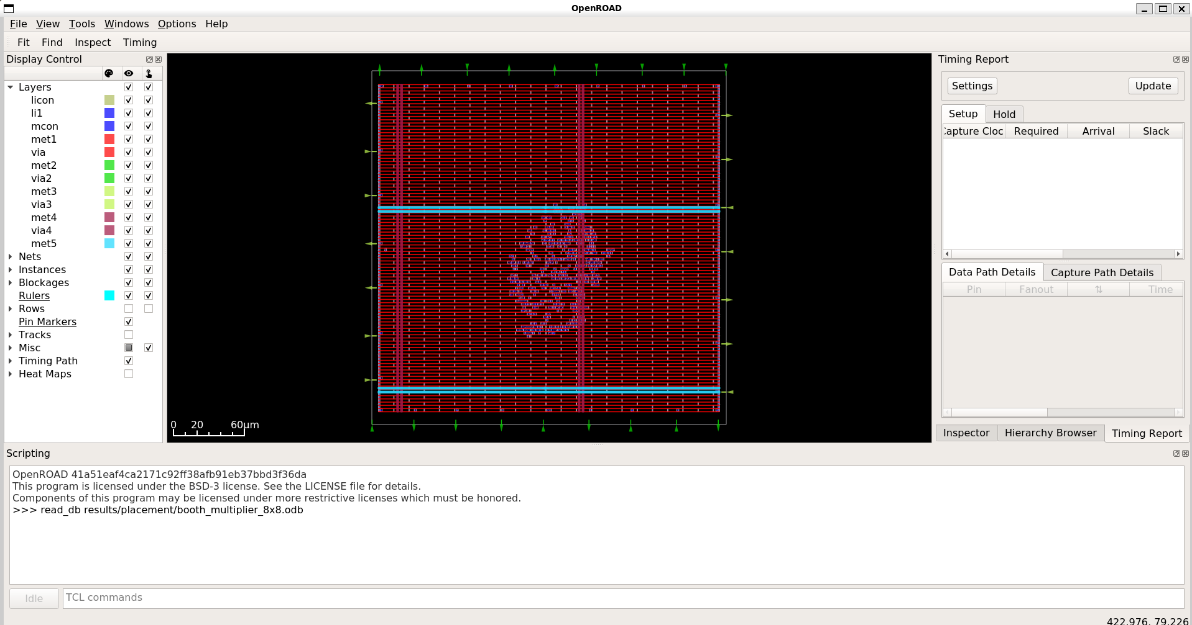
Placement
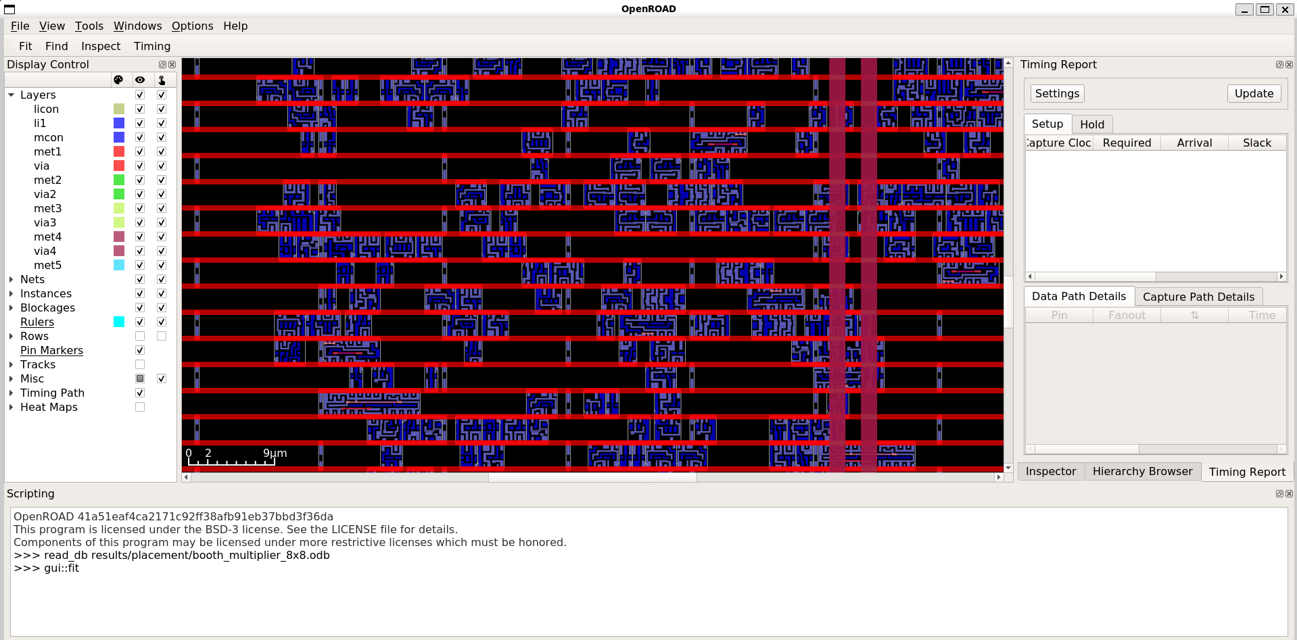
Routing
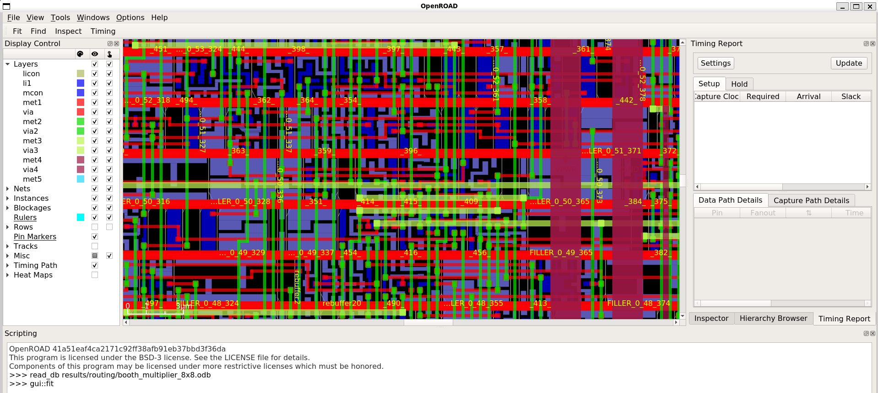
Final GDSII Layout
